**DEPARTMENT:**

**PROJECT TITTLE:** VISITORS REGISTER MANAGEMENT SYSTEM

**SUPERVISOR:**

**DOCUMENT TYPE:** **PRESENTED BY:**

**ADMISSION NO:**

**COURSE:** COMPUTER SCIENCE

2017

# DECLARATION

I declare that the project that presented here as student of Diploma in Computer Science at ARUSHA TECHNICAL COLLEGE is my own original work and has not been copied or presented elsewhere.

**Candidate Names** **Signature**

Godson Davis Shau ………..…………………..

**Supervisor Names Signature**

Mr. Baraka Mtakati ………..…………………..

# ABSTRACT

The main purpose of this project is to design and develop a visitor’s register management system that will help improve security by providing a safe way to store all the visitors and control visitor’s activities. The system will provide interface where a user can register a visitor, a visitor pass printed on a small paper, a dashboard where the status of visitor’s visiting will be presented. The system will be controlled by the System Admin and each user will be provided with his/her personal account for ensure accountability.

# ACKNOWLEDGMENT

Firstly I would like to acknowledge and thank God for everything that is doing and continuing to do for me in my life, but also my family for the support their showing me in every step I make.

I would also like to acknowledge my tutors and my supervisor Mr Baraka Mtakati for his great ideas towards my great achievement.

Lastly but not least, I would like to acknowledge gate keepers and my computer science class members and those of information technology for their great contribution assuring that this project comes to success.

**TABLE OF CONTENTS**

DECLARATION ii

ABSTRACT iii

ACKNOWLEDGMENT iv

LIST OF FIGURES vi

1.0 Description vi

Figure1: Figure1: use case representing proposed system............................ vi

LIST OF TABLES vii

CHAPTER 1 1

1. Introduction 1

1.1 General introduction 1

1.2 Historical background 1

1.3 Problem definition and specification 2

1.4 Project objectives 2

1.4.1 General objectives 2

1.4.2 Specific objectives 2

4.1 Significance of the Project 3

4.2 Scope of the Project 3

4.3 Limitation of the Project 3

CHAPTER 2 4

LITERATURE REVIEW 4

2.1 The existing system 4

2.1.1 Disadvantages of existing system 4

2.2 Proposed system 4

2.2.1 Advantages of a proposed system 4

CHAPTER 3 5

3.0 METHODOLOGY 5

FIGURE1: USE CASE REPRESENTING PROPOSED SYSTEM 6

3.1. Phases of prototype based methodology 8

CHAPTER 4 9

4.0 DATA COLLECTION 9

4.1 Interview: 9

4.2 Review of the data collection: 11

4.3 Data evaluation 12

4.4 Cost estimation 13

CHAPTER 5 14

5.0 System Development 14

5.1 Languages used to develop the system 14

5.2 Hardware requirements used to run the system 14

5.3 System Description 15

5.4 CHALLENGE FACED DURING IMPLEMENTATION 18

CHAPTER 6 19

6.0 Recommendations. 19

6.1 Conclusion 19

6.2 REFERENCES 20

# LIST OF FIGURES

## 1.0 Description

# Figure1: Figure1: use case representing proposed system..............................................................5

Figure 2: Data Flow Diagram Representing Proposed System.......................................................6

Figure.3: Prototyping Diagram………………………………………… ……………...…………7

Figure 4: Pie Chart………………………………………………………………………………...8

# LIST OF TABLES

Table 1: Name Of Few People Interviewed.....................................................................................8

Table 2: Results Of Review Data Collection.................................................................................10

Table 4: Cost Estimation................................................................................................................13

# CHAPTER 1

# Introduction

## General introduction

**Visitor’s register management system** will help improve security by providing a safe way to store all the visitors and control visitor’s activities. The system will provide interface where a user can register a visitor, a visitor pass printed on a small paper, a dashboard where the status of visitor’s visiting will be presented

Now day’s security has become a major priority in most countries, due to the sensitive information a company or organization holds or a mass of people receiving cant courante safety, the system is required so as to have a record of all visitors received in time and to also control the visitor’s access locations.

## Historical background

Currently most places the use of books and paper sheets are used to record visitors which they do not guarantee the safety and pure of the information gathered.

But also the current method is hard to capture intruders since there were no pass or anything with visitor’s info to identify him.

Gathering visitors report could take time plus the records used a lot of space for storage.

## Problem definition and specification

The main focus of the system is to focus on data capture and record for data security purpose so as to provide an easy followup incase anything goes wrong.

## Project objectives

The objectives of this project have been categorized into two main parts namely general and specific objectives.

### General objectives

The Overall Objective of this System is to:

Design a Visitor Register Management system that that will fulfill user demands.

### Specific objectives

* A login interface for users.
* A simple Visitor registration form.
* Creating a Database for storing all the information's.
* Interface for admin to create and restrict users.
* Interface for viewing and printing reports for admin and view reports for authorized users.

# 

## Significance of the Project

* Ensure security, since visitors will be provided with passes to identify their authorization so intruders may be easily noted.
* Availability of visitor’s records, if anything happens visitors records can be used to identify suspects, you just need authorization.
* Theft, visitors can’t get out of area especially sensitive places with properties not belonging to them because every item associated with will be recorded.
* Time track, Will help identify time taken by each visitor.
* User friendly, Easy to navigate, forms easy identify inputs.
* Activities tracking, Keep track of all visitors’ activities.

## Scope of the Project

## The System is universal, it is designed to be used at any location, type of business, organization, and obviously anywhere security is given priority.

Due to time duration, the system will deal with only new visitors.

## Limitation of the Project

* This system will run to all platforms like Android, Windows & Mac Os.
* Supported by all Browsers.
* All database will based on MySQL database.

# CHAPTER 2

# LITERATURE REVIEW

This chapter describes the feature and operation of existing system and the proposed system suitable to solve the problem which has been explained. Also by analysing the existing system and the proposed system as well as the block diagrams for both current system and proposed system.

## The existing system

The existing system “gate pass system” was designed to be used at collages and universities and could not manage uninvited visitors, but the ***Visitors Register management system*** will cover uninvited and invited visitors with an advance feature of printing visitors pass.

### Disadvantages of existing system

## Unable to handle uninvited visitors.

## Did not provide a record of items associated with a visitor.

## Can’t be used in different area apart from colleges and universities, not even private institutes.

## Proposed system

**Visitor’s registry** is the system for tracking everyone who enters your building, office, company, hospital ward, school visit and a lot more.

A visitor may be a customer, an employee friend, a job applicant, a business partner, or an office rival. Essentially, anyone who is not a regular full-time employee is a visitor.

The system will ensure security of the data captured but also the security on the work place.

### Advantages of a proposed system

* Data storage will be secured
* Visitors records will be easy to access and on time
* Intruders will be easily identified
* It saves time on second visit since records will be in place
* Improve Security.

# CHAPTER 3

# METHODOLOGY

This system will be implemented by using Agile model of development, agile model is chosen according to the requirement are not well known, and I want to breaking the system into cycles to easy produces the release when update occur in the system and also produce a good documentation of the system.

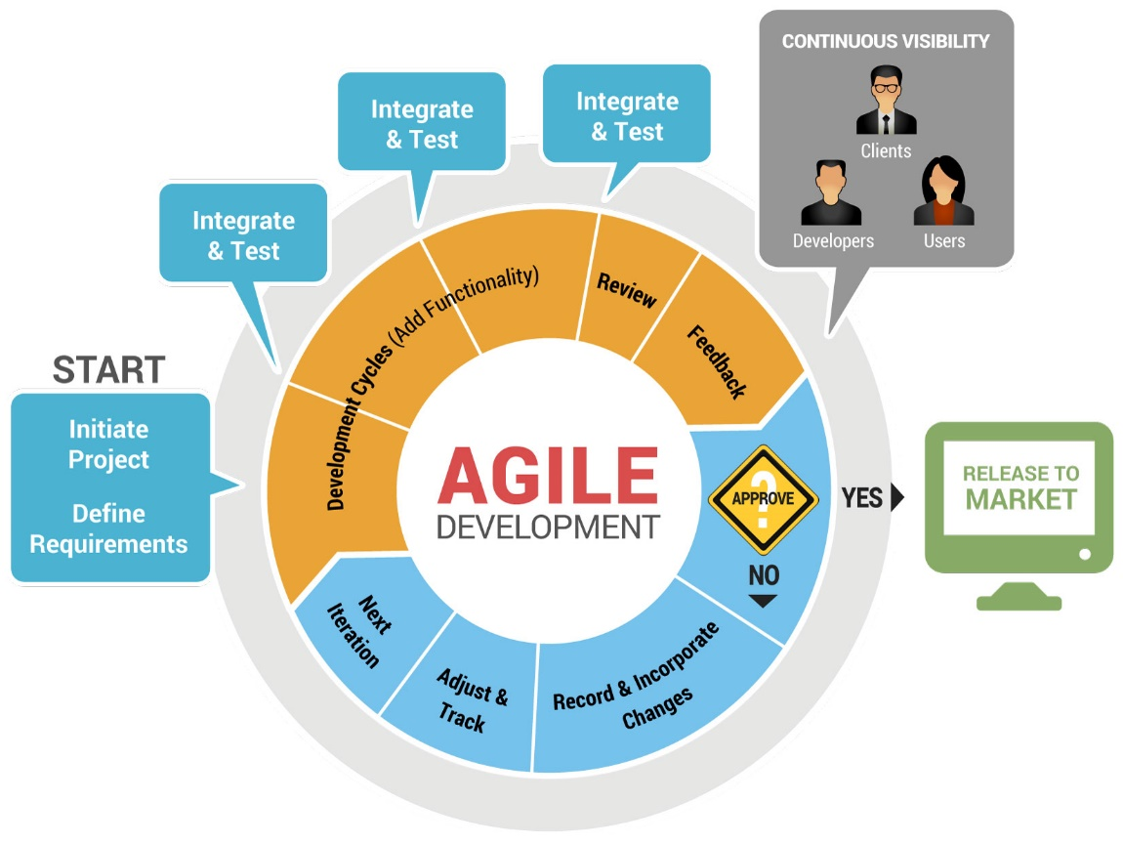

*Figure 1. Agile diagram*

# FIGURE 2: USE CASE REPRESENTING PROPOSED SYSTEM

**VISITORS REGISTRATION MANAGENMENT SYSTEM**

**Gate Man**

**visitors**

**View report when authorized**

**Managers**

**Manage Users**

**System**

**Administrator**

**FIGURE 2: DATA FLOW DIAGRAM REPRESENTING PROPOSED SYSTEM**

**System Administration**

**Gate Man**

**Post Visitors information Login**

**Login**

**Manage Users**

**View Authorized Reports ` View and Manage Reports**

**Visitors Registration**

**Management system**

**View Reports**

**Manager**

**Login**

**Manage Users**

**Database design**

This describes the concept of designing the database. This includes the tools used to design your system.

* **Design phase**

This phase decide how the system will operate, in terms of hardware, software and network infrastructure, the user interface form and reports that will be used with specific programs, databases and files that will be needed. The system design accomplish through four steps which are design strategy, architecture design, database and file specification and program design.

* **Implementation phase**

During this phase, the system is either developed or purchased, this phase is usually the longest and most expensive part of the process.

# CHAPTER 4

## 4.0 DATA COLLECTION

Data collection is a term which used to describe a process of preparing and collecting data. The purpose of data collection is to obtain information about the system including the problems and features users require.

I was required to collect data that will give me an overview of the way the current system looks like which will help me in designing the proposed system.

The methods which were used to collect data are **interview based on oral form**. This method involves the process of asking and answering questions using verbal communication, normally the process consists of interviewer and respondent.

### 4.1 Interview:

**Table 1: NAME OF FEW PEOPLE INTERVIEWED**

|  |  |  |  |
| --- | --- | --- | --- |
| **No.** | **NAME** | **SEX** | **POSSITION** |
| 1 | Mr Gaudence Ndimbili | Male | Ultimate security guard |
| 2 | Miss Omega Charles | Female | visitor |

#### 4.1.1 Interviewing Mr Gaudence Ndimbili

1. **Analyst:** How do the current visitor registration favour you?

**Mr Gaudence:** the current manual system is challenging since it is very hard to retrieve visitors information when needed.

1. **Analyst:** Is there a record of item user is associated with on his/her visit

**Mr Gaudence:** we normally don’t record the items because even when needed will be giving yourself a hard work to fetch the info.

1. **Analyst:** What are the challenges in storing the visitor’s information?

**Mr Gaudence:** The most problem we face is when .we need the information from a year back, finding the sheets takes a lot of time and sometimes are lost permanently

1. **Analyst:** What can u say about the proposed system on solving the problems you’re facing on the current system?

**Mr Gaudence:** it’s a game changing system giving as a chance to cope with the digital environment, simply will make my work easily and smart.

#### 4.1.2 Interviewing Arusha technical Visitor:

1. **Analyst:** How is your experience on current visitor registration system?

**Miss Omega:** On my visits, there were no security maintained since not all my information I accurate placed due to sometimes being in hurry.

1. **Analyst:** Do the guards remember all the items you were associated with on entry time?

**Miss Omega:** AbsolutelyNo

1. **Analyst:** What the problem do you facing using the current system?

**Miss Omega:** even when I was invited to visit a certain location, I had problems proving that.

1. **Analyst:** What can u say about the proposed system on solving the problems you’re facing on the current system?

**Miss Omega:** The system will give me confident while visiting on invitation and even when not since I will have my visit pass.

**Note: About six peoples where interviewed but only two I choose to display their interview because most of them where based on this answers.**

4.2 Review of the data collection:

Due to the data we collected by interviewing six persons, below is the table shows results and suggestions of the three interviewee that agreed our system.

**TABLE 2: RESULTS OF REVIEW DATA COLLECTION**

|  |  |
| --- | --- |
| **Interviewee** | **Results** |
| Mr Davis Shau | Was impressed with the idea and believed it will excite both visitors and users. |
| Miss Judith Agrey | Agreed on the project but was more concerned on the technology. |
| Mr Epaflas Juma | Agree my proposed system is going to solve the problem. |

## Cost estimation

**TABLE 4: COST ESTIMATION**

|  |  |  |  |
| --- | --- | --- | --- |
| **Requirement** | **Description** | **Description** | **Proposed Source/s** |
| Internet and stationary services | Buying internet bundles, printing documents and photocopying | 50,000/= | Personal income |
| Transportation | Travelling do feasibility study, and visit other professional | 20,000/= | Personal income |
| Resources | Printer | 150,000/= | Personal income |
| Communication | Voucher for communication | 30,000/= | Personal income |
| **TOTAL** | | **250,000/=** | **Personal income** |

# CHAPTER 5

# 5.0 System Development

The system I develop needs some software and hardware requirements .So all the requirements should meet to make it developed and function properly. There are also languages (tools) used to develop the system which assist me to make it useful.

# 5.1 Languages used to develop the system

I use different tools to design and implement my system. I use programming languages such as PHP script, MySQL database, html language and CSS styling language.

**Html**-Stands for Hypertext Mark-up Language

**CSS**- Stands for Cascading Styling Sheet

**PHP**- Stands for Hypertext Pre-processor

**MySQL**-Stands for My Structured Query Language

**HTML language,** I use this language for making web pages which usually appear in browser

**CSS styling language,** I used this language for styling my system to make it appear in different style or shapes

**PHP script,** I use PHP script to connect my system with MySQL database, using MySQL statements to have all connections with the database

**MySQL database, I** used MySQL database to create, store, retrieve and modify data in the database.

## 5.2 Hardware requirements used to run the system

The system developed under the following minimum requirements Ram 2 GB, Dual processor and hard drive 250GB but maximum requirements also can be used to ensure high efficiency of the system.

# CHAPTER 6

## 6.0 Recommendations.

The project (systems) that we use to design is a very good idea because it make a student to know many things concerning the project, for myself I have learned different languages such as php, html all these it is because of project. But I recommend the issue of project to be assigned during second year so as the student to have enough time to implement the project but for third year to start issues of projects it is a big challenge and it costs us a lot especially myself, so syllabus (modules) should be done for the second and third year to provide enough time for a student to perform well. When a student will study maybe the php the first semester of second year it provide good time for the student to practice with that language and be aware of other languages and first semester of third could be very simple to implement the system.

Also the time is not enough to implement all the required features, due to time limitation I could not fulfil all features and if time could be enough the system should be run in different languages such as VB (Visual Basic), Android, Asp.net responsively.

## 6.1 Conclusion

The visitors Management system will be simple and user friendly dedicated to help handling visitors registering process and improve security in both visitor’s items and company or organization equipment’s.

## 6.3 Recommendations

The system will be very helpful in maintaining data security, the system will be cost effective and will provide a best experience in management and visitors handling.

## 6.2 References

* Standish Group (2012). CHAOS report. Author, Boston.
* PMI (2013). A Guide to the Project Management Body of Knowledge (PMBOK® Guide) - Fifth Edition, Project Management Institute (PMI).
* <https://en.wikipedia.org/wiki/Project_management>
* <https://www.bitrix24.com/>
* <https://www.zoho.com/projects/?utm_source=capterra&utm_medium=cpc&utm_campaign=zprojects>